(Translation from Russian)

Balance +100

How to play:
- Managing your player, you must reach the portal that opens after blanking pulses.
- To manage the player is very simple. Tilt your device to move in the required direction.
- Go around the obstacles and enemies, which will learn at a more complex level.
- Move the boxes to release the path.

Features of the game.
- It is controlled by the accelerometer (balance).
- A large number of levels.
- Beautiful graphics.
- Save the completed levels.
- Dynamic gameplay.

Basic information
- All major scripts in JavaScript;
- All important images in the format .psd;
- Sprites are divided into basic layers that you can edit in any graphic editor;
- The script is quite simple and flexible;
- All the main files are divided into groups;
- All saving is done using PlayerPrefs;

The setting of the game.
The application icon.
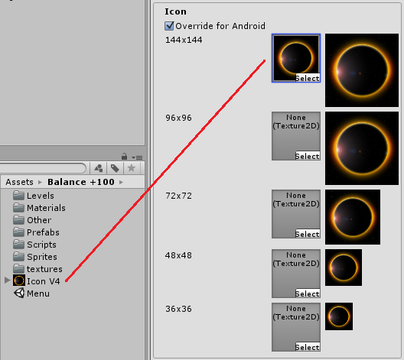

Setting the scene in the Build Settings.

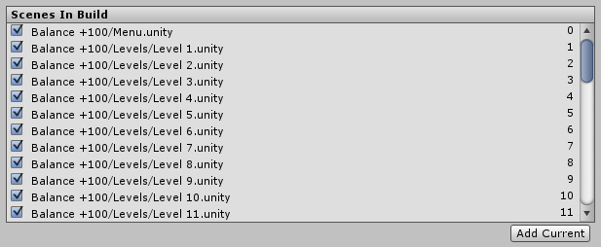

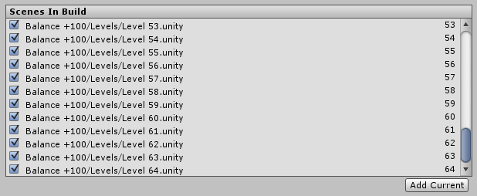

Hierarchy and assignment
* Folder "Levels"
This folder contains all the game levels. You need to configure as shown above.

* Folder "Materials"
The folder contains all the materials that are used in the game. Also there is one physical material for the interaction of the player with borders and blocks.

* Folder "Other"
Inside the folder "Animation" which contains several animations for the movement of the light sources in the menu.

* Folder "Prefabs"
All major game objects added to the prefabs and are located in this folder.

AI / AID - The game object that chasing our player.
BlokTransformBlue - The unit, which can only be moved.
BlokTransformRed - The unit, which, when touched, the player takes away health.
Border - The border at all levels.
FairLine - The fire, which takes a player's health. Consists of particles.
Finish - Finish which sets the player, when you collect all the Points.
Line - Has like “FairLine” but unlike him, after the player is not in line, health continues to be taken away.
ParticleLoss - Particles which Express the explosion of the player, i.e. the loss.
Point - The pulses, which need to be collected throughout the level.
SpotlightOnSprite - A light source that illuminates the border.

* Folder "Scripts"
All scripts used in this game. They know you below.

* Folder "Sprites"
> Folder "Levels"
All the sprites that are directly related to the playing part.

> Folder "Menu"
Sprites intended for the menu.

> Folder "Space"
Sprites depicting the background of the game. There are two identical sprite, those with the word ...Blur - blurred copy. It is made for the gradual blurring of the image that the player is not distracted by the background!

* Folder "Textures"
And in this folder all the textures that use particles and other game objects. You can easily keep track of which corresponds to each texture by name, or by looking in the folder "Materials".

Description scripts

“BlurEffects” - This script is designed to blur the background at the start of the game. It requires 2 objects. 1) Sprite blurred background. 2) Sprite space which is visible at the start. After blur, it disables unnecessary sprite (2). Blur is carried out by increasing the alpha channel.

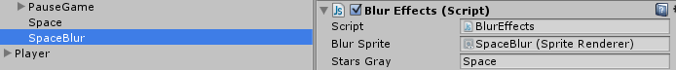

“FonRotation” - Rotates background in the main menu of the game.

“LightMenu” - Replaces the animation for the light source in the menu, which covers the table with the levels.

“Music” - If you are going to add music, this script will help you transfer it between scenes without interruption.

“NextLevels” - The script, which weighs on the player and counts the number of Points taken and when all is taken includes the finish.

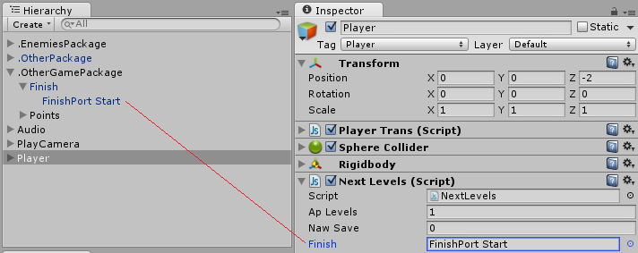
“Ap Levels” - The total number of points.
“Naw Save” - The number of taken points.

“PauseGame” - The script is intended to effect a pause in the game. Clearly you can see in the "PlayCamera" - "PauseGame" (at any level in the hierarchy).

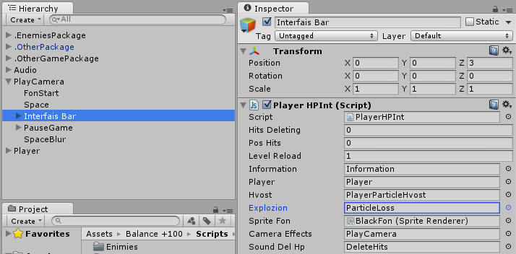
“PlayerHPInt” - Important script that is responsible for the health of the player and the display strip health.

“PlayerTrans” - Moves the player using the device's accelerometer Android. Hanging on the player in the hierarchy. Just make the camera follow the player.

“PointControl” - Carries out the control Points.
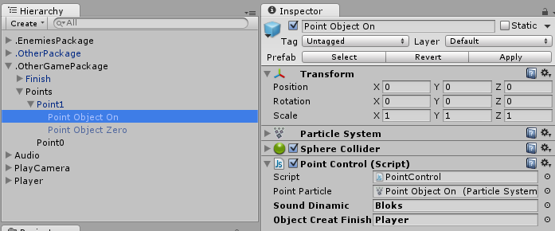
“Point Particle” - Particles that are managed by the script when you contact them.
“Sound Dinamic” - The object, which is activated when the capture Point. The object hanging Audiosource.
“Object Creat Finish” - The player in the hierarchy. It is necessary that the script "NextLevels" monitored the total number of Points.

«Enimies»

“Border” - Responsible for subtraction of health, upon contact with triggers. (AI, bloks)
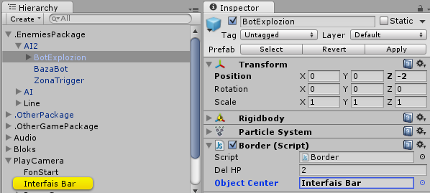
“Del HP” - The speed of taking the health.

“Object Center” - The object on which hangs the script "PlayerHPInt", which considers overall health.

“BorderParticle” – Similar to previous, but with respect to the particles. Also requires the player in the hierarchy to slow its movement after touching particles. To do this, tick the "This Line".

“BotTrigger” - Manages AI.
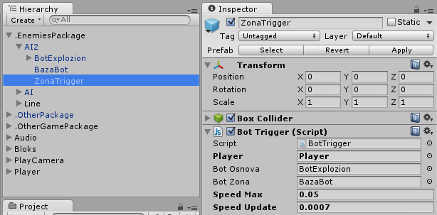
To adjust its range, set the trigger to find on this object.

“BotOsnova” - Itself the enemy.
“BotZona” - The reference point of the enemy.
“Speed Max” – Max. Speed the AI.
“Speed Update” - Acceleration speed.

“TransformObject” - In some cases, you can do that the enemy had their own path consisting of the key points. The enemy goes from one to another and so on. There are 10 key points.

«Finish»

“FonBar” - When you start gradually makes transparent black sprite that gives the effect of enlightenment.
Hanging in the "Play Camera"- "Fon Start".

“PortFinish” - Responsible for the finish.

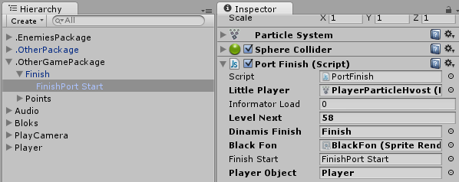
“Little Player” - Particles of the player.
“Level Next” - The number of the next level.
“Dinamis Finish” - The object with the sound of the finish line.

«Menu»

“Assess” - When a player leaves the game, it is proposed to evaluate the game.

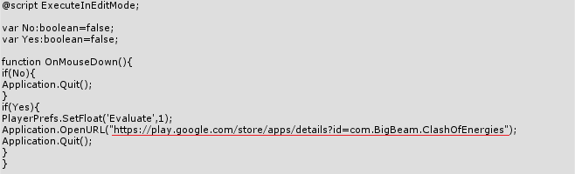
Accented by a row address, which moves the player pressing the button "Evaluate"

“EffectsDoing” - If effects are enabled, activates the first object.

“EffectsSett” - Responsible for setting up effects. You can see it in the hierarchy in the scene menu.

“Exit” - Responsible for leaving the game.

“LanguageRender” - Is responsible for the display language in the game.

“LangugeSetting” - Responsible for the language setting. You can see it in the hierarchy in the scene menu.

“LevelsGo” - Responsible for the transition into the game.

“NextList” - Turning tables levels.

“Open” - Monitors have completed levels.

“Play” - Responsible for pressing the play button.

“Sound” - Sound setting in the game.

Additionally

1) When the player presses the block to the border, it slides along the border. This property must be used on many levels.
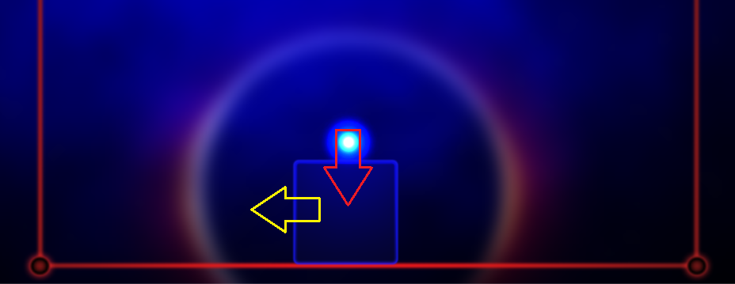

The structure of the hierarchy
«Menu»

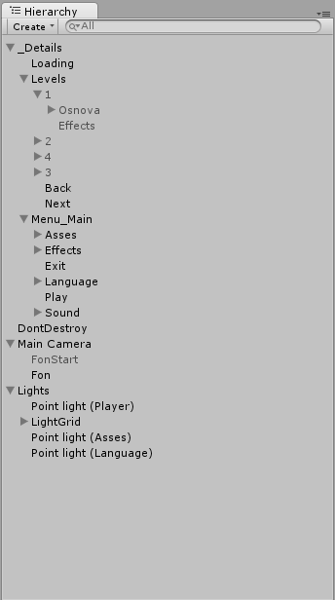
1. “_Details” - All main.
“Loading”- the inscription load level.
1.1 “Levels” - Panel levels. On each of the 4 panels is 16 levels.
“Back” and “Next” - Arrow switch panels.
1.1.1 “1” - The first panel.
“Effects” - The grid, which is illuminated by the light source.
1.1.1.1 “Osnova” - There are colliders, each of which when clicked takes you to the desired level.
1.2 “Menu_Main” - Inside the appropriate button on the main menu.

“DontDestroy” - The object is not destroyed when switching levels. Ideal for background music and your other plans.

2. “Main Camera” - Luggage, inside which are the background of the game and the “sprite enlightenment”.

3. “Lights” - The light sources that illuminate different layers.

«Levels»

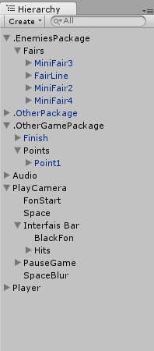
1. “.EnemiesPackage” - This object contains all the objects that hinder the player.
2. “.OtherPackage” - Border level.
3. “.OtherGamePackage” - Important objects.
3.1 “Finish” - Finish
3.2 “Points” - All the points needed to finish.
4. “Audio” - Inside some of the objects on which you can hang the sounds. They are activated at the right time.
5. “PlayCamera” - Camera with additional important objects.
5.1 “FonStart” - The effect of the enlightenment and darkening.
5.2 “Space” - Detailed background.
5.3 “Interfais Bar” - Bar games. This object is the main script which considers health.
5.4 “PauseGame” - Everything needed to pause.
5.5 “SpaceBlur” - Blurred background.
6. “Player” - Player. Inside of which there are particles, particles at a loss and the light source.

Thank you for your purchase.

@ For additional questions, please contact the email: vip.7andrey@mail.ru
We wish you good luck in your work.
Sincerely, Andrey Oleynik.

